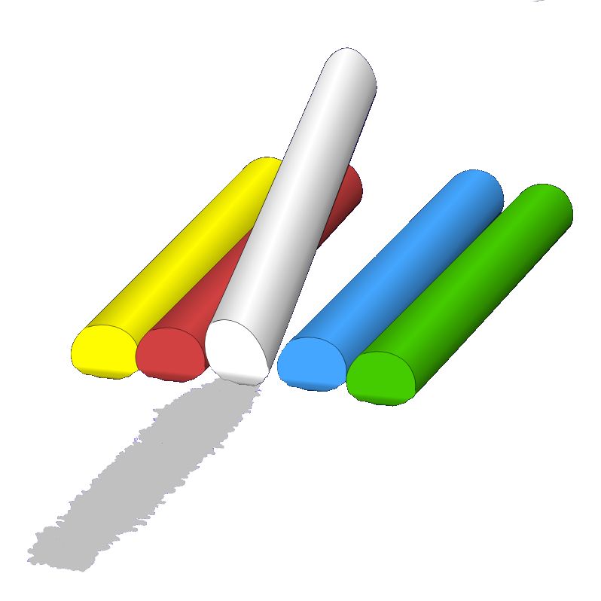
DRAWING
Draw your Favourite Flower below.

COLORING KEY:

Orange Yellow

Pink Blue

Brown Purple

Green Red

