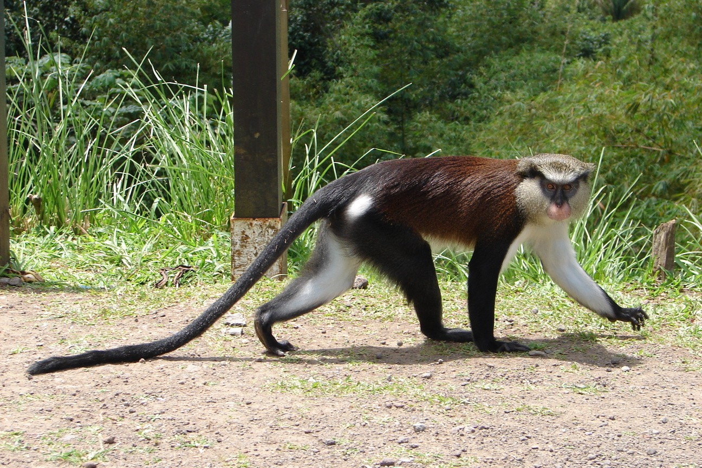
MONA MONKEY

Draw a picture of the Mona Monkey

